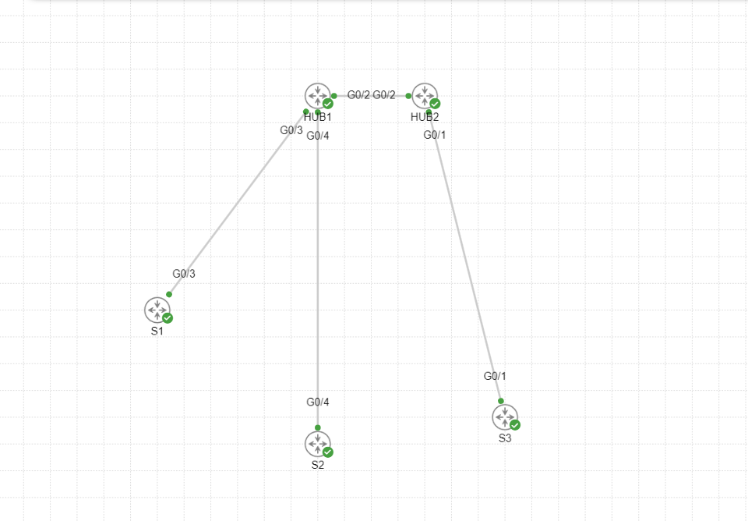

|  |  |  |  |  |  |  |  |  |
| --- | --- | --- | --- | --- | --- | --- | --- | --- |
|  | G0/0 | G0/1 | G0/2 | G0/3 | G0/4 | Loopback | VLAN | Tunnel |
| HUB 1 | - | - | 160.1.7.2/24 | 160.1.8.1/24 | 160.1.9.1/24 | 5.5.5.5/32 | 1 | 192.168.1.1 |
| HUB 2 | - | 160.1.5.1/24 | 160.1.7.1/24 | - | - | 2.2.2.2/32 | 1 | 192.168.2.2 |
| SITE 1 (S1) | - | - | - | 160.1.8.2/24 | - | 6.6.6.6/32 | 1 | 192.168.1.3  192.168.2.3 |
| SITE 2 (S2) | - | - | - | - | 160.1.9.2/24 | 8.8.8.8/32 | 1 | 192.168.1.5  192.168.2.5 |
| SITE 3 (S3) | - | 160.1.5.2/24 | - | - | - | 3.3.3.3/32 | 1 | 192.168.1.4  192.168.2.4 |